CS 255 System Design Document

UML Diagrams

UML Use Case Diagram
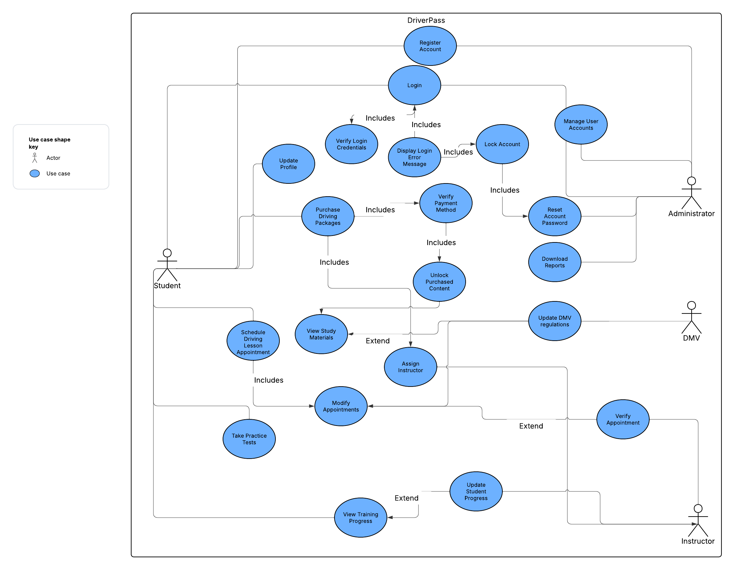

UML Activity Diagrams
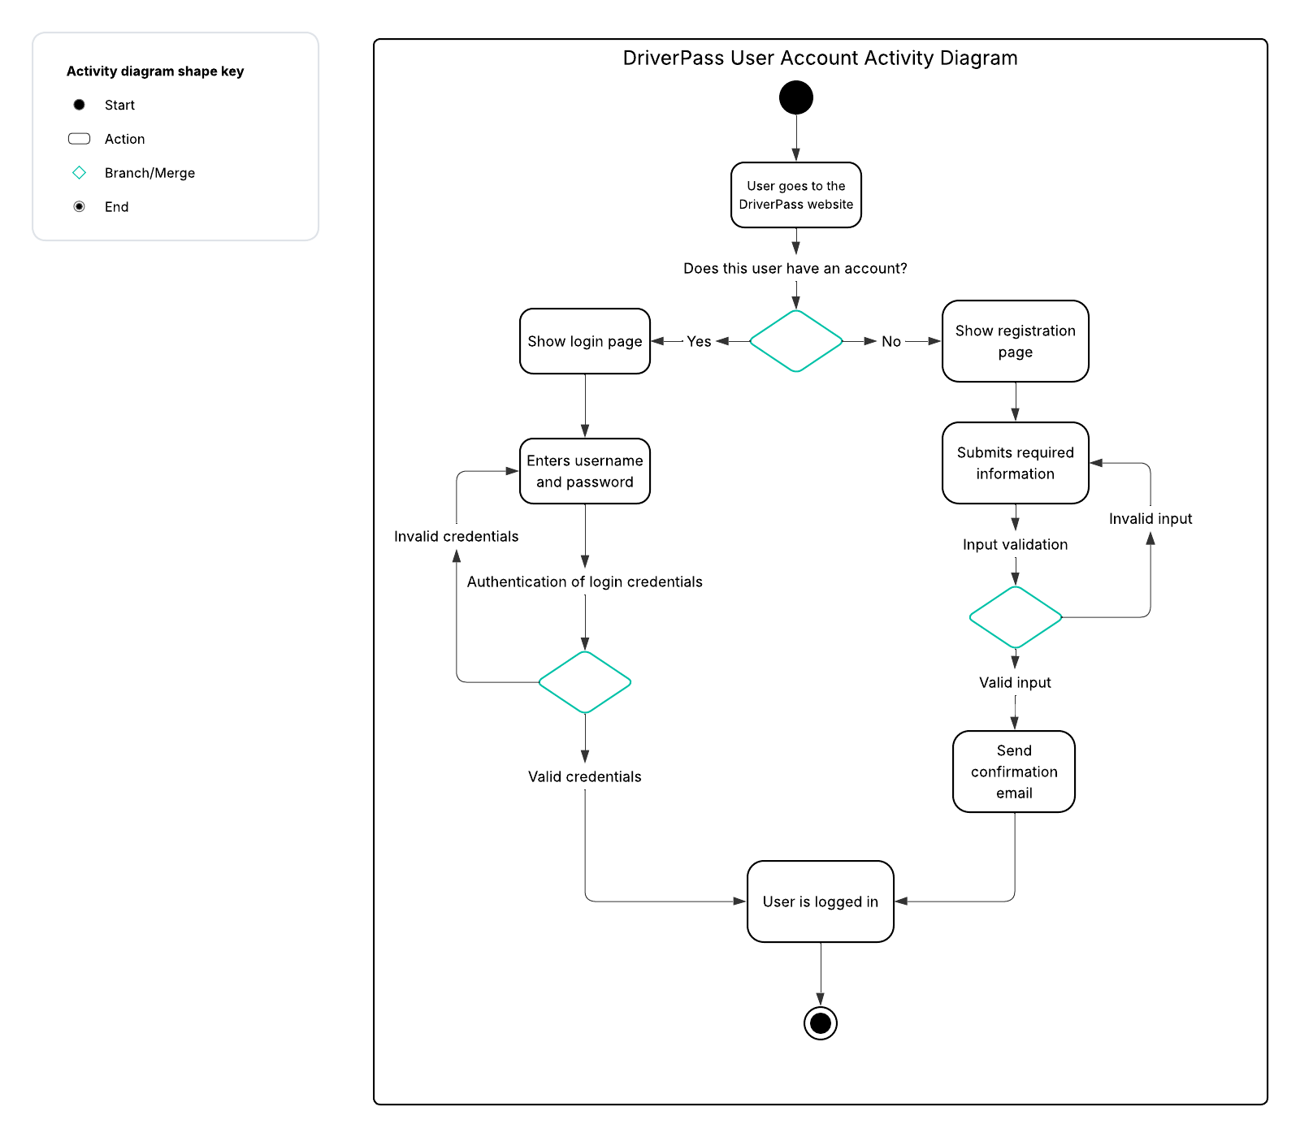

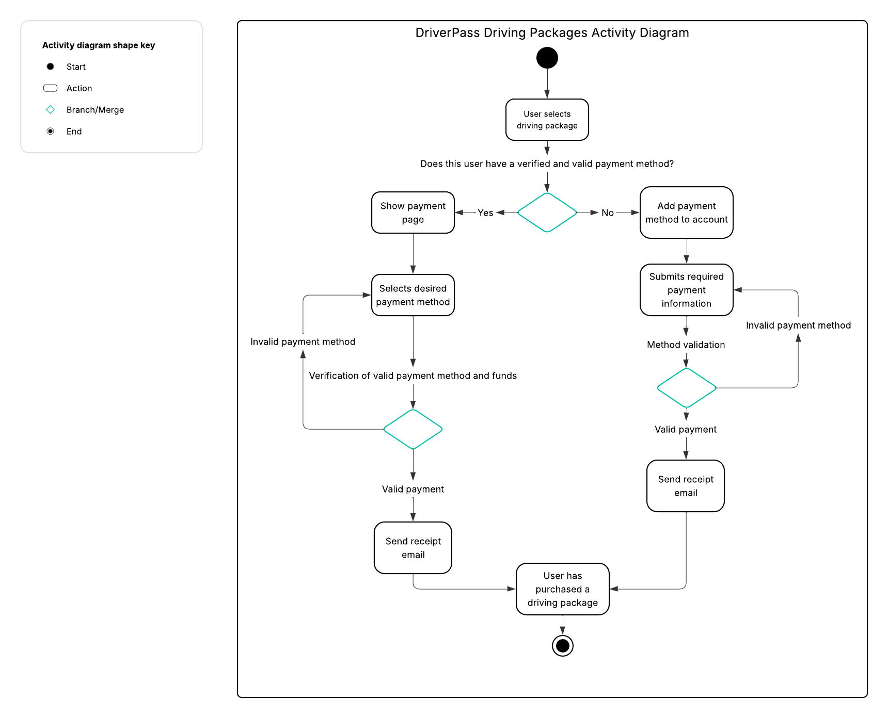

UML Sequence Diagram
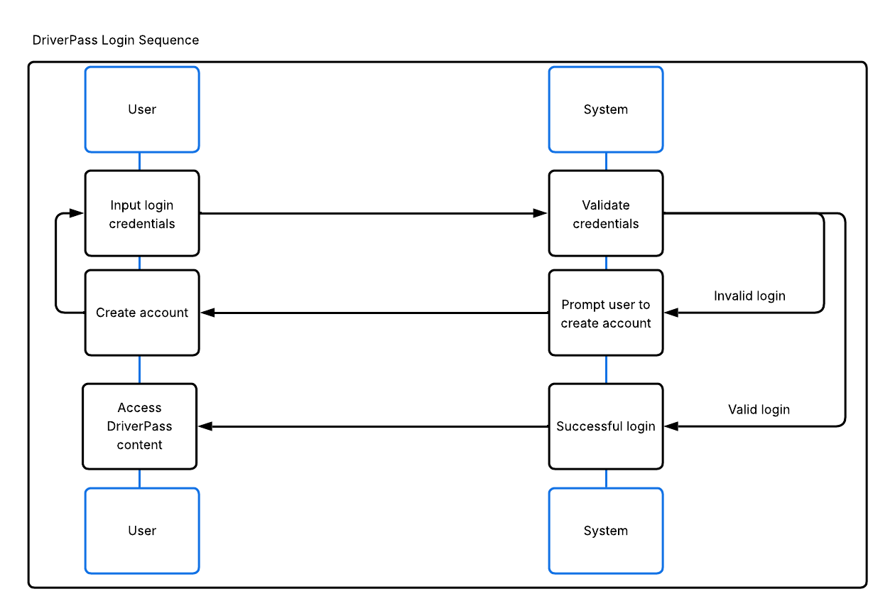

UML Class Diagram
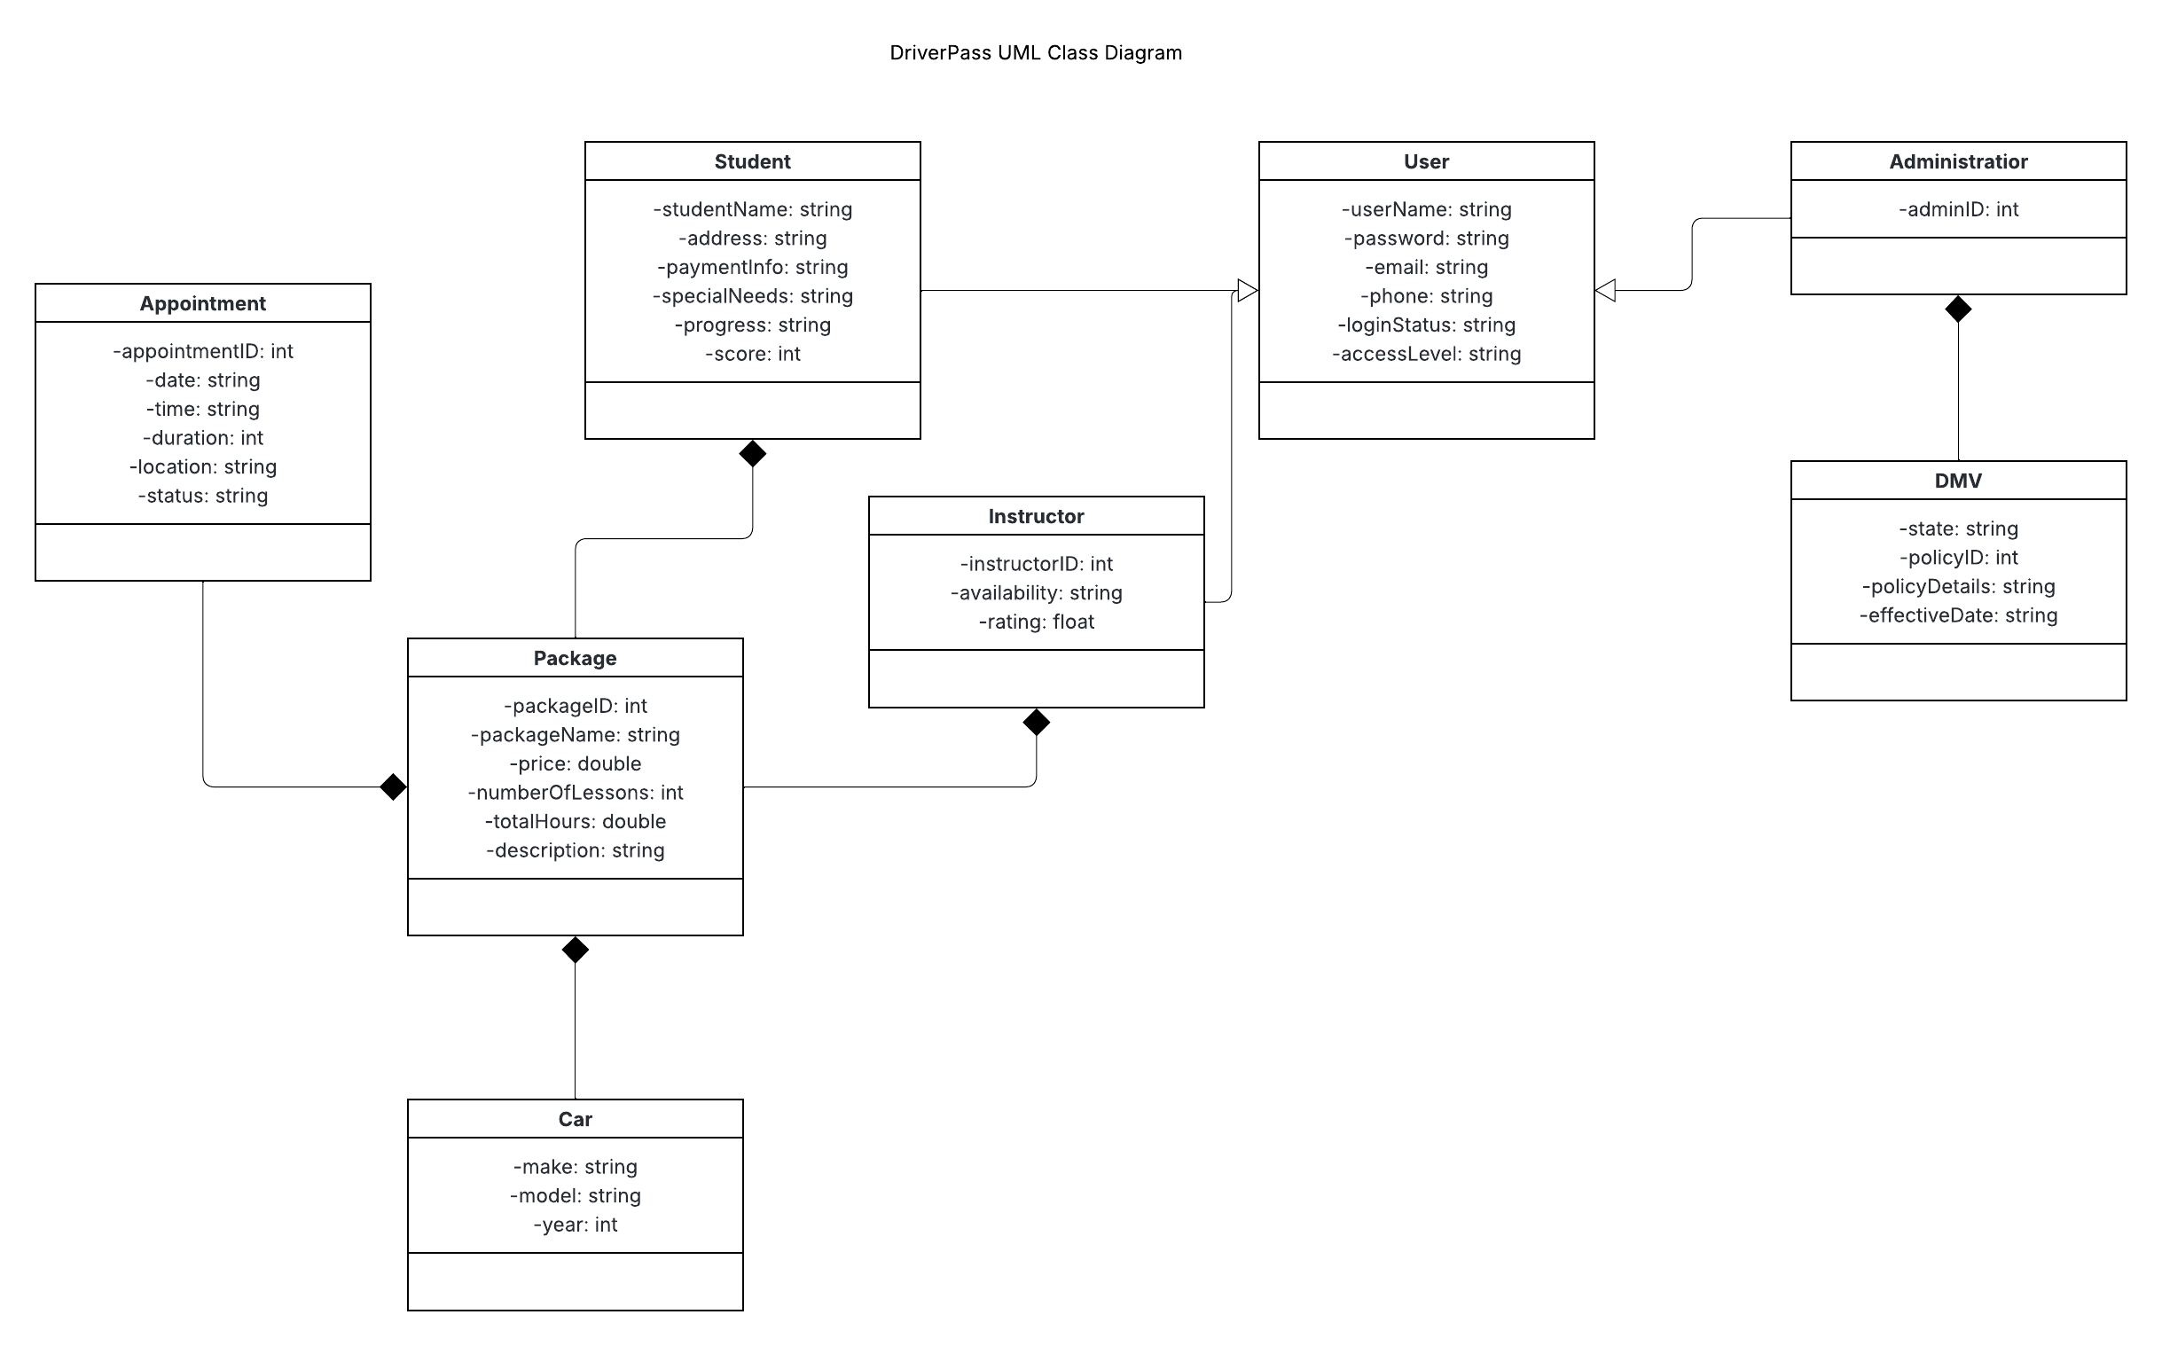

Technical Requirements
The required hardware for the DriverPass system is as follows:
- A physical or virtual server to handle user traffic and application logic.
- A secure dedicated server for storing data safely, accessible through the web server.
- Users should have a laptop, desktop, or mobile device (phone, tablet) with an up-to-date web browser to access DriverPass.
The required software for the DriverPass system is as follows:
- A Linux-based operating system.
- Apache web server.
- MySQL database.
The required tools for the DriverPass system are as follows:
- SSL
- TSL
- Multi-factor authentication
- Three dashboards for the different user types: Student, Instructors, Administrators
The infrastructure required for the DriverPass system is as follows:
- A strong internet connection.
- A two-tier server system: one public-facing for the site itself, and the aforementioned database server for the back-end.

